WEST LONDON WASTE AUTHORITY
Report of the Projects Director | 23rd June 2023
Programmes Update
SUMMARY
This report provides an update on the WLWA Programmes.
- Borough data is a critical deliverable for the progression of two of the core savings areas in the Reuse and Social Value and the Digital Twin Programmes.
- Working together across the climate emergency teams will enable us to create consistency of message and to optimise our resources to maximum benefit.
- The Communications and Reuse and Social Value programmes will deliver savings by reducing residual waste and returning items in to use with new owners.

RECOMMENDATION(S)

- The Authority is asked to note the progress outlined within this report.
- The Authority is asked to note the importance of aligning priorities and working in partnership in order to increase the chances of successful delivery.

- Introduction
The WLWA programmes are in the budget for three years from 2023 and are designed to enhance the efficiency of the waste management system across collections, treatment and disposal whilst moving towards a new model for how waste and resources are managed to achieve a carbon neutral west London. All programmes support WLWA’s strategic priorities.
The Communications programme - will measure the levels of knowledge, engagement and participation of residents across the region. This will be used to create new and direct messaging to help shift residents’ approach to waste reduction, material diversion and recycling resulting in more efficient use of the services already provided. It will also produce joint communication campaigns covering west London boroughs designed to increase participation in and correct usage of collection services.

The Reuse and Social Value programme is designed to deliver a system change to the HRRC services, it will focus on efficiency of the HRRC operations and material diversion whilst delivering financial savings and social value. The programme will support the creation of more circular economy activities that are economically viable and sustainable.

The Digital Twin programme will consolidate Borough and WLWA data and provide collection routing efficiency savings. Collating the service data will enable officers to identify trends and opportunities to drive further efficiency in our joint waste system and provide a basis for modelling the required changes to service delivery from the Environment Act (Extended Producer Responsibility EPR, Consistency of Collections and Deposit Return Scheme DRS).

The Food Waste programme has invested in borough infrastructure since 2021 to expand the reach of the food waste recycling service. It is focused on expanding residents’ access to collection services across all property types. In conjunction with the communications programme WLWA are also working with Boroughs to identify new ways of operating and expanding collections services to cover additional materials such as e-waste, textiles and any extended producer responsibility product trials.

Progress
  - The Communications programme
Officers have completed soft market testing for resident insights communications work and are currently exploring the most effective procurement methodology.
A joint in-person workshop for Members and Senior Managers in all boroughs is being planned to identify common priorities in the Boroughs Climate Emergency communications including waste, and to commit to collaborative campaigns where possible to deliver the culture shift needed.
The west London Communications Officers group are working to identify joint resources and projects to generate efficiencies and consistency in messaging to residents.

  - The Reuse and Social Value programme
Since 1 April 2023 the capacity for reuse at Abbey Road has been increased with the completion or a new workshop and storage area for bicycle repair. From January to March 2023 112 bikes were diverted from recycling and re-distributed to local families. In April 2023 31 bicycles were re-distributed.
The repair and distribution of laptops and tablets from the Fixing Factory at Abbey Road HRRC has been increasing since the project began in August 2022. From August until March 2023 548 laptops destined for the e-waste recycling stream were assessed for repair. Of the laptops collected, a total of 71 (12%) laptops were fixed, and of these, 52 (9%) have been donated to local people. In April 2023 16 laptops were re-distributed.
Officers are engaging with Boroughs to identify additional measures to reduce the costs incurred through the whole system from HRRCs. This includes new operations and handling of waste streams as well as procuring material off-take to leverage best value through economies of scale.

  - The Digital Twin programme
Officers have completed soft market testing to look at options to find a partner to undertake routing efficiency investigation. A specification is currently being drafted with the aim of commencing a procurement during quarter two.
Borough collections data has been requested from Harrow, Hillingdon and Hounslow as their data will be the first inputted into the digital twin. Once the baseline is complete options for increasing efficiency of collections will be explored.

1.4. The Food Waste programme
Progress on the expansion of food recycling services was reported in the March 2023 report. During 2022/2023 the number of households receiving the food recycling service increased by 29,410.

- Risk
2.1 Communications

There is a risk that… | Which will result in … | Management Actions Implemented or Planned | Owner | RAG
Divergent communications priorities, timescales and resources between and within borough waste and climate services at both member and officer level. | Slow development of shared messages.  Contradictory messages are promoted. | All Climate emergency stakeholders engaged through Borough Communications teams and Joint Communications Officers group. | Boroughs | Amber
Incomplete or lacking detail in Borough waste and recycling service data. | No data being provided to form the basis of a campaign.  Delays in production of campaigns.  Inability to target messages | Standing agenda at Borough Partnership meetings  WLWA self-service portal. | Boroughs | Amber
Lack of bidder availability and experience for a new climate and waste insights programme | Work being delayed.  Poor quality or inaccurate results. | Soft market testing of suppliers and deliver procurement through an output driven specification. | WLWA | Green

2.2 Reuse and Social Value
There is a risk that… | Which will result in … | Management Actions Implemented or Planned | Owner | RAG
Lack of suitable site availability for Circular Economy hubs | Being unable to trial the model and get a better understanding of how it can work.  Social Value benefit not realised or valued. | Utilise Borough and WLWA sites where possible, identify regeneration area opportunities.  Usage of LOOP Social Value tool including analysis of benefits to Borough. | Boroughs/  WLWA | Amber
Limited availability of partners for the repair/offtake of items | A smaller range and/or number of items being moved in to reuse  Social Value benefit not realised or valued. | Exploration of Third sector, existing off-taker and circular business engagements.  Usage of LOOP Social Value tool including analysis of benefits to Borough. | WLWA | Green
Slow delivery of change at Borough sites will affect the efficiency of the project (take longer to reach break-even) | A longer timeframe to meet the financial savings and realise the efficiencies. | Regular meetings with boroughs at Operational, Officer, Director and Member levels.  Use Abbey Road information and data to indicate potential benefits. | Boroughs | Amber
Inability to demonstrate success without timely Borough financial information and data. | A longer timeframe to meet the financial savings and realise the efficiencies. | Operational management and information is not in WLWA control. Build stronger partnerships.  Use Abbey Road information and data to indicate success and continue. | Boroughs | Amber

2.3 Digital Twin
There is a risk that… | Which will result in … | Management Actions Implemented or Planned | Owner | RAG
Incomplete or lacking detail in Borough waste and recycling service data. | No data being provided to form the basis of the digital twin.  Delays in creation of the digital twin.  Inability to deliver the savings resulting from the potential efficiencies | Standing agenda at Borough Partnership meetings  Environment Directors group and Borough Partnership owners of the data requests. | Boroughs | Amber
Borough framework for rerouting options may restrict scale of savings. | Lower than anticipated savings as a result of efficiency changes | Early identification of policy framework for collections and develop options analysis for the services | Boroughs | Amber
Programme risks include the continuing loss of material from the existing recycling and diversion systems which will result in high ongoing disposal cost and will not meet recycling or carbon targets.
Further planned management actions include effective integration with other programmes and projects, which will be managed through regular reporting and the governance process.
- Financial Implications
All programmes are within budget with no spend has been committed other than employees salaries year to date April 2023. The anticipated savings across the programmes are as follows;
  - Communications Programme
The anticipated saving for the programme in year one is c.£200k. This is likely to be achieved through greater understanding of the existing systems with more efficient use of existing services and a reduction in residual waste as material is captured in the correct stream, for example food recycled instead of binned and a reduction in the contamination of dry mixed recycling. Savings will also be generated with the use of new services such as the Material Collections Service (MCS), service modelling suggests a saving from one active Borough of c.£125K would be possible in 23/24 compared to the previous financial year. In addition, staff resources in boroughs are likely to be saved with joint communications campaigns.
  - Reuse and Social Value
The savings identified in the Social Value and Reuse programme as a result of operational efficiencies at HRRC sites and borough WTS were estimated to be around £533k in year one through a combination of HRRC sites efficiencies, solar energy investments and increasing reuse. There is also social value to be generated as a result of reusable items such as bicycles being made available to people who need them.
In April 2023 a new joint contract for recycling of paper and card from four borough HRRC sites commenced. The annual forecast for the savings from this is c.£146k across the four boroughs.
  - Digital Twin
Previous routing efficiency work resulted in indicative savings around £300k per annum for one borough across waste and recycling services. The potential savings are dependent on a number of factors including current efficiency levels and scale of change. Savings will be generated once baseline data has been provided and the collection routes are changed.
4.4. Food waste
The savings delivered through the food waste investment were detailed in the March report and will be updated in September. Further savings will be generated as a result of materials diverted from residual waste in to reuse and recycling streams. For example in 2022/23 kerbside collected textiles increased by 13%, resulting in a saving of £2,100 against disposal costs.
- Staffing Implications – The Projects and Circular Economy team is currently 1.5FTE understaffed and officers are recruiting a Project Manager and a 0.5FTE job share for the Circular Economy Manager.
The Social Value and Reuse Programme is 1.0FTE understaffed, the Net Zero Planning Policy Officer vacancy is currently being recruited.
- Health and Safety Implications – None
- Legal Implications – None

- Impact on carbon reduction
All programmes aim to move materials from disposal as waste to recycling, or further up the waste hierarchy to reuse reduces the carbon impact of waste and the carbon impact of purchasing new items.
The Digital Twin has the potential to significantly reduce vehicle movements, the carbon impact of fuel and fleet usage and to inform decisions about new collection methodologies which can continue the reduction of carbon generation through more efficient collection services.
- Implications for the Environment Directors
The programmes are a key element in delivering the Environment Directors priorities in the next two years. The four priorities are shown below, supported by examples:
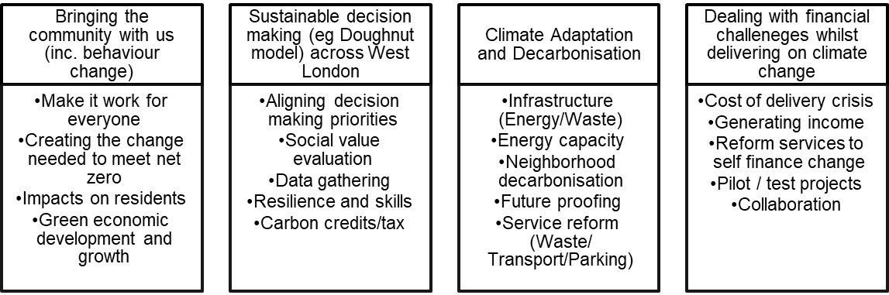
Key areas include behaviour change, data gathering, resilience and skills, social value evaluation and future proofing the system.
- Joint Waste Management Strategy
A key factor in the Joint Waste Management Strategy is the 65% recycling target. To meet this a framework of a joint plan for 2030 to be developed by WLWA and Boroughs was agreed in March 2022. The joint plan must incorporate managing the rising cost of inflation which can only be countered in WLWA by reducing the amount of waste collected.
It is vital in this year that we:
- Develop joint communications campaigns and target areas of low participation in recycling services to divert recycling away from rubbish.
- Preventing waste at source in the household reuse and recycling centres by diverting items in to reuse.
- Pulling together collections information across west London to increase data quality and develop understanding of links between services and making who whole system data readily available to all boroughs.
The agreed framework is shown below:
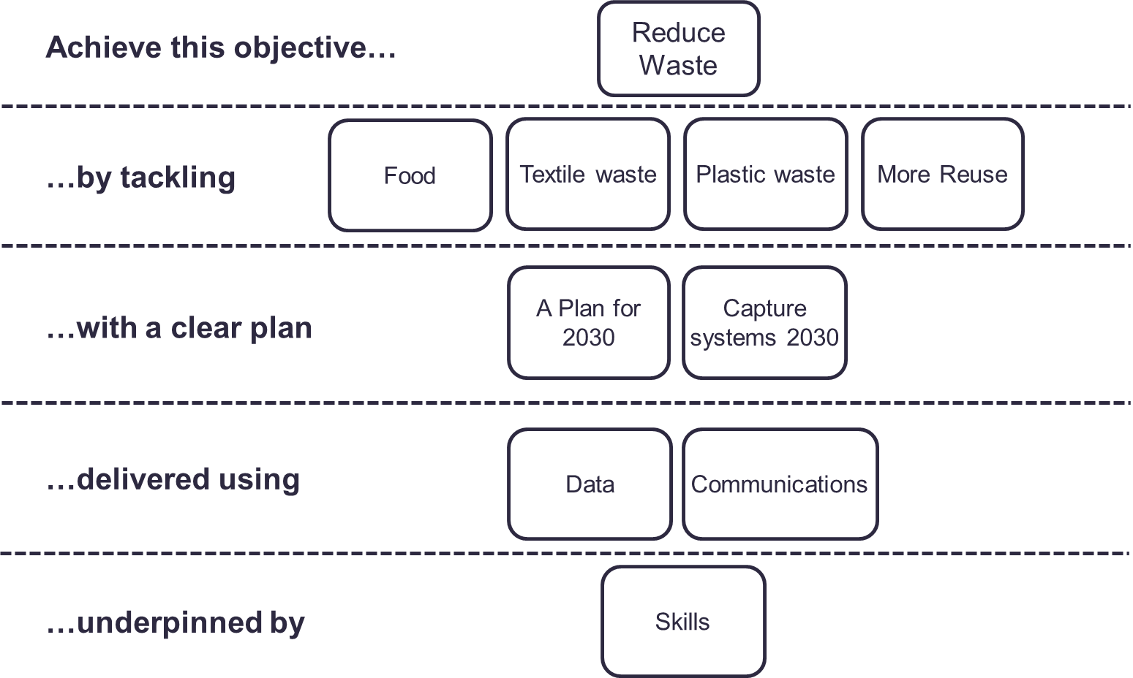
The programme is intrinsically linked to the Authority’s Joint Waste Management Strategy and Business Plan. The projects are driving the design of the new policies and programmes through data, best practice and identification of opportunities, as well as delivering change to meet the desired outcomes and targets in the Strategy and the Budget.

Contact Officers | Peter Tilston, Projects Director 07796 271713  petertilston@westlondonwaste.gov.uk  Motoko Doolan, Net Zero Carbon Manager 07917 075876  motokodoolan@westlondonwaste.gov.uk  Sarah Ellis, Strategic Development Lead 07584 631710  sarahellis@westlondonwaste.gov.uk

